MP letter writing guide
How to write a letter to your MP
Find your MP’s name and contact details at https://members.parliament.uk/members/commons. Enter your school’s postcode and write to the MP of the constituency where your school is located.
MPs receive many letters. Therefore, keep yours short (no longer than one side). Write a brief introduction, make two or three key points and conclude by asking your MP to urge the Foreign Secretary to push for an immediate ceasefire in Yemen and stop the export of weapons from the UK to Saudi Arabia.
If you have practised persuasive writing in English, include some persuasive phrases in your letter.
Either email your letter to your MP from your school email address, or hand write it and post it to your MP at: House of Commons, London SW1A 0AA
Format your letter accurately. Write your name and school address in the top right-hand corner of the page. Directly underneath and on the left of the page write your MP’s name and House of Commons address. Address your MP as; ‘Jane Jones MP’. Then write your letter underneath leaving a blank line between paragraphs. Sign off your letter ‘Yours sincerely’.
Tell Oxfam when your school receives a reply from your MP by emailing jmclaverty@oxfam.org.uk
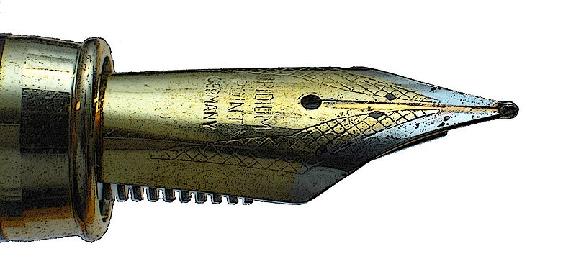
Points to include in your Yemen letter – select the most relevant
Decide which two or three points are most important to include. Here are some facts, figures and requests to select from.
- Air strikes and fighting in Yemen are destroying food and water systems. Almost 80% of the population (20.7 million people) needs humanitarian assistance.
- 4 million people are displaced by conflict.
- Up to 19 million people in Yemen are food insecure.
- The conflict is taking a terrible toll on children. 2.2 million children are acutely malnourished.
- Saudi Arabia is leading the bombing campaign in Yemen, in coalition with nine other countries.
- All sides in the conflict are accused of harming civilians, but according to the UN the majority of civilian casualties have been caused by attacks by the Saudi-led coalition.
- Between 2015 and 2019 the UK signed off export licenses for arms worth £6.2b to the Saudi-led coalition fighting in Yemen
- The Arms Trade Treaty clearly states that weapons sales should be stopped where there is a risk of International Humanitarian Law being broken.
- The UK should do all it can to demand an immediate ceasefire to end the suffering in Yemen
- The first case of COVID-19 was reported in Yemen in April 2020. By June 2020 it is estimated that cases have topped 1 million. Yemen’s health system cannot cope.

See the topic guide for references to the statistics. They are up to date for March 2022
There is a downloadable postcard template in the resource for shorter MP messages. Include these messages from students along with your MP letter(s).
Image: https://commons.wikimedia.org/wiki/File:Fountain-pen-nib_white1.jpg

Terms of use
Copyright © Oxfam GB
You may use photographs and associated information in this resource for educational purposes at your educational institution. With each use, you must credit the photographer named for that image and Oxfam. You may not use images and associated information for commercial purposes or outside your educational institution. All information associated with these images relates to the date and time the project work took place.

