Crisis in Yemen Topic Guide

Introduction

‘Two in three Yemenis do not know where their next meal will come from’

Yemen, located on the southern tip of the Arabian Peninsula, has experienced almost continual crises and violence since the uprising against British colonial rule in Aden during the early 1960s. Following the unification of North and South Yemen in 1994, the new Democratic Republic of Yemen plunged into civil war. Guerrilla warfare continued into the 2000s and popular protests spread during the ‘Arab Spring’ of 2011. Armed conflict then intensified in March 2015, and to-day it involves several factions including the military forces of neighbouring Saudi Arabia. All sides in the conflict stand accused of violating international humanitarian law.

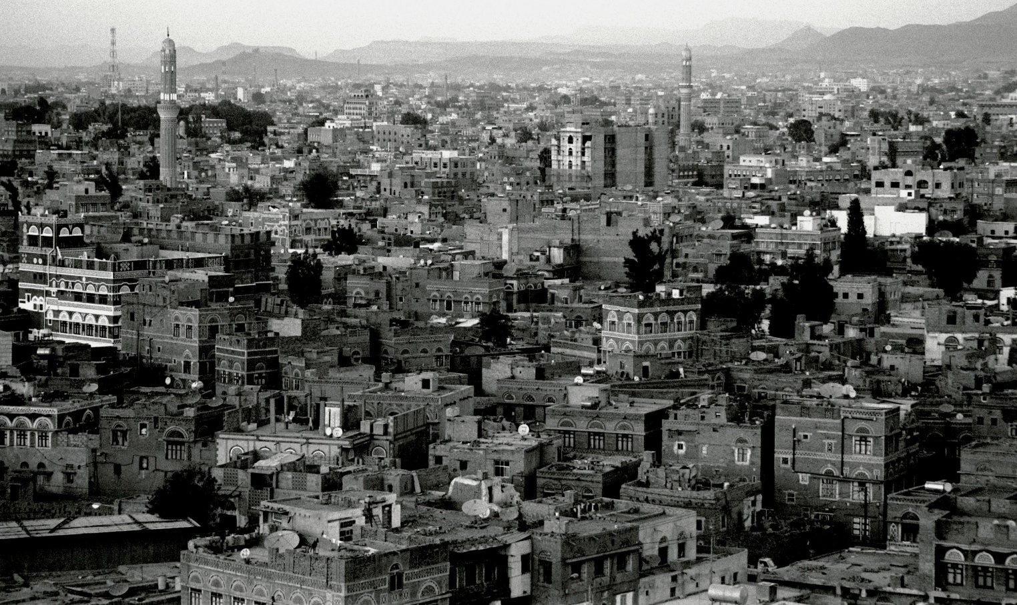
Sana’a, the capital city of Yemen Photo: Chris Worrall/Oxfam (2004)

The combination of intense conflict and fragile governance has forced 4.2 million people to flee their homes and has placed 20.7 million people – almost 80% of the population – in need of humanitarian assistance. Food production and trade have collapsed under the strain of conflict, with the economy shrinking by 50% since violence escalated in March 2015. Spikes in the violence, such as the blockade of Hudaydah port in November 2017, street fighting in Sana’a in December 2017 and the Hudaydah offensive of June 2018, mean that the humanitarian emergency has intensified even further.

The puzzle of the Yemen crisis is that, while UK humanitarian aid to Yemen has been generous, the British government has also supplied weapons to the Saudi-led coalition who are active combatants in Yemen’s conflict. Oxfam calculated that the UK granted 1,697 arms export licences worth £6.2 billion to members of the Saudi-led coalition between 2015 - 2019. The value of these export licences is more than eight times the amount of aid (£770m) given by the UK to Yemen over the same period.

Campaigners are clear that the Arms Trade Treaty prohibits these sales of weapons to a government involved in a conflict where international humanitarian law is being violated by all sides.
Hillside in Taiz, Yemen. Photo: Chris Worrall/Oxfam (2004)

The UK Government has deflected this criticism and claimed that its arms sales to Saudi Arabia do not contravene the Arms Trade Treaty and international humanitarian law. Campaigners continued to challenge these arms sales in the UK courts. In June 2019, The UK Court of Appeal ruled that the sale of UK arms being used by Saudi Arabia in the war in Yemen were unlawful.

As part of their judgement the Court of Appeal explicitly noted the discovery of a fragment of a guided bomb supplied by the United Kingdom at the site of an attack on Abs Hospital in Hajjah governorate. 19 civilians were killed, and a further 24 civilians injured in this attack.

Despite this evidence, and following a review which controversially concluded that airstrikes which contravened international humanitarian law were ‘isolated incidents’, in June 2020 the UK Government announced it would resume issuing export licences for the sale of arms that could be used in Yemen. This decision continues to be challenged in the courts, with a hearing expected during 2022

A further paradox of this situation is that the UK is the “Penholder” on Yemen at the UN Security Council and has a responsibility for leading and brokering peace negotiations. This role is undermined by the fact that UK-made arms continue to cause death and suffering to innocent Yemenis caught up in this violent conflict.

Yemen’s first case of COVID-19 was reported on April 10th 2020. By June 2020 the UK Government estimated that infections already topped one million, many times the numbers recorded by the official statistics. War and now coronavirus have overwhelmed the country’s depleted health facilities. In a country where doctors have struggled for many years to obtain equipment, there is a severe shortage of Personal Protective Equipment (PPE) and Intensive Care facilities to respond safely to coronavirus. Only around half of healthcare facilities are currently functioning across the country. The mortality rate from COVID-19 in Yemen was estimated by the UN to be as high as 30%, well above anywhere else on the planet. At the end of 2021 only 2% of Yemen’s population had been vaccinated for Covid-19

Oxfam and its partners are calling on the UK Government to do his utmost to push for an immediate ceasefire in Yemen, stop selling arms immediately to all parties in the conflict, to take forward the UK’s responsibility as the ‘penholder’ at the UN to find a lasting peace and to ensure adequate funding to enable a sustained humanitarian response and rebuilding the country.

The global ceasefire

On 23 March 2020 UN Secretary-General António Guterres called on all warring factions in the world to agree on a global ceasefire so humanity could focus its attention on fighting COVID-19 and building opportunities for lasting peace. Yemen is only one of many countries afflicted by long-term conflict. Others include Afghanistan, South Sudan, Central African Republic, Ethiopia, Colombia and Ukraine. This resource provides an in-depth examination of one such conflict. However, young people could research other conflicts around the world, examine what they have in common, what makes each one unique, and ask whether there is a common roadmap to peace (or a common cause of conflict) that applies in each of these different circumstances.

Using this resource

This resource consists of the following sections

- This introduction topic guide.
- A PowerPoint presentation introducing the Yemen crisis. This may be presented either by teachers or young people and the script may be amended accordingly.
- A brief ‘Opinion Continuum’ workshop activity to encourage critical thinking about the Yemen crisis and other conflicts.
- A suggested action guide with links to the Yemen Crisis appeal and a campaign action for young people.
- A Yemen action postcard which may be sent electronically to your MP or printed and posted

Yemen is both a complex emergency and a controversial issue. Below are some questions about modern conflicts raised by the crisis. They could be raised with young people in a broad and balanced discussion. There are no straightforward ‘right’ or ‘wrong’ answers. Oxfam’s Teaching Controversial Issues guide supports teachers to raise these types of challenging questions in classroom work. In addition, the guide also provides advice about supporting students to take ownership of the actions they may wish to take in response to learning about the crisis.

- How effective is humanitarian aid during an armed conflict?
- What should the priorities be for meeting the needs of civilians?
- How can the infrastructure and public services be maintained or improved? Is this possible while the conflict continues?
- How can conflict be brought to an end?
- Is there a relationship between humanitarian aid and peace?
- How can the parties in a conflict be held to account for observing international humanitarian law?
- Do all conflicts around the world receive equal international attention? What decides how much attention a conflict receives?
- What should the rules governing the sale or transfer of arms from one state to another be?
- Should Britain supply arms to one side in a conflict? What are the arguments for and against?
- How can a long-lasting peace be built in a region which has experienced prolonged conflict?
- What is the most appropriate response to a conflict for young people to make?

Using this resource in primary schools

The Yemen crisis raises challenging moral issues and judgments, and the resource should be adapted to make it accessible at KS2.

- The PowerPoint presentation provides a comprehensive introduction to the Yemen crisis. However additional time should be allocated to ensure that younger children fully understand its content.
- An ‘opinion continuum’ activity works well with young people of all ages. However, the statements may need to be simplified and explained to younger children in greater detail.
- It may be more straightforward for the teacher to suggest that younger children either fundraise for the Yemen crisis appeal or participate in the campaign action.

Schools campaigning during the COVID-19 pandemic
We appreciate that the COVID-19 pandemic has placed unique restrictions on the everyday life of schools and the campaign activities young people undertake. We also believe that campaigning and civic engagement during the pandemic are good for young people’s (and adults’) wellbeing and sense of empowerment. However, campaigning should always be safe and carried out according to the COVID-19 regulations and/or advice in place at the time. Therefore,
- The materials in this pack are suitable for classroom use, blended learning or home learning with minimal adaptation.
- The activities may be completed face-to-face in school or online and returned to school
- We encourage young people to meet their MPs as MP meetings are an important element of civic education and youth empowerment. However face-to-face meetings with MPs and visits to Parliament have not been possible while COVID-19 regulations have been in place. Therefore, as an alternative, we suggest writing to MPs and, where possible, arranging online meetings. This situation may change as the country emerges from the pandemic.

Taking campaign action

The action guide is written for young people to lead campaigning on Yemen with the support of their school and/or family. The actions are;

1. Learn and teach others about Yemen.
Skills: building understanding, communication and confidence – raising awareness
2. Lead others to make and display Doves for Peace.
Skills: craftivism, leadership and communication
3. Write to your MP.
Skills: citizenship, leadership, communication. There are downloadable postcard templates for multiple messages.
4. Fundraise for the Yemen crisis appeal.
Skills: citizenship, leadership, communication

We suggest young people begin by learning and teaching others, and then plan their next actions choosing from and/or combining Doves for Peace, writing to their MP and fundraising depending on their interests and the time available.

Background reading
References
Statistics and information about the crisis in Yemen go out of date quickly. The OCHA Yemen website is a useful source for regularly updated information. The most recent update at the time of writing is March 2022 - https://www.unocha.org/yemen
Campaign Against the Arms Trade (2022) – The War on Yemen’s Civilians
ACAPS (2020): Yemen Crisis Impact Overview
Oxfam (2019): UK Arms and Aid in Yemen
Oxfam (2018): The World Must Back Peace, Not War, To Put An End to Civilian Suffering in Yemen
Oxfam (2015): British Aid and British Arms: A Coherent Approach To Yemen
Oxfam (2016): Yemen’s Invisible Food Crisis
Oxfam Yemen Crisis Appeal
Control Arms: The Arms Trade Treaty
Wikipedia: Modern History of Yemen
Oxfam (2018): Teaching Controversial Issues
Schools for Future Youth (2017): Skills Development Learning and skills development activities for young campaigners

Terms of use
Copyright © Oxfam GB
You may use these photographs and associated information for the educational purposes at your educational institution. With each use, you must credit the photographer named for that image and Oxfam. You may not use images and associated information for commercial purposes or outside your educational institution. All information associated with these images relates to the date and time that project work took place.

UNFPA (Sept 2020) – UNFPA Response in Yemen
UNHCR (Feb 2022) – UNHCR Operational Update
UNOCHA (December 2018) – Humanitarian Needs Overview
Oxfam (September 2019) - https://bit.ly/34b36JP

