This report is the 5th Annual Learning Review and it provides an overview of OGB complaints activity and any related actions/learning during 2015-16. The report contains 5 sections: a Synopsis followed by separate sections on the Complaints Group, Programme, Trading and Supporter Relations. The Programme, Trading and Supporter Relations sections are structured in the same manner: Progress and Actions, Trends and Figures and Learning and Actions. The report also includes 2 appendices: (1) Report against 2015-16 Action Plan and (2) 2016-17 Action Plan.

Synopsis

- Complaints Group - the group met twice during the year to review complaints activity and share learning. Good progress was made on objectives during 2015-16 with a number of completed actions. Those actions outstanding have been reviewed, and, where relevant, carried over into 2016-17. For example, finalisation of the harmonised Complaints Policy has been delayed, so the group agreed that OGB’s policy will remain active until the OI policy comes into force.
- Programme - during 2015-16 (as with 2014-15) there were a small number of complaints reported in the QMR. The low number of complaints means there is little learning possible for the organisation.
- Trading - following the trend of recent years complaints about Trading Division activity decreased in 2015-16 (406 (2014-15) vs 365). Despite this overall decline, poor customer service complaints have increased to a level similar to that reported in 2014-15. The 14 day resolution target also remains challenging.
- Supporter Relations - in comparison with 2014-15 figures the overall volume of recorded complaints has decreased slightly (3160 vs 2751). Despite this there has been an increase across most of the fundraising channels, Telemarketing, Supporter Mail, Door to Door and Street Fundraising; an area of major attention and media coverage last year. In 2015 Oxfam did increase its overall fundraising activity and the increase in Oxfam’s complaint rate linked with this activity is still below the sector’s complaint rate for 2014.

Programme
Progress and Actions
The vehicle for reporting significant complaints about our programme is the Quarterly Management Response (QMR). During 2015-16 (as with 2014-15) there were a small number of complaints reported in the QMR which has meant there is limited opportunity for learning within the organisation.

The International Programmes Team (IPT) agree that the level of recording and reporting complaints is too low and acknowledge that complaints handling needs to be higher on priority list for change to happen. Transitioning to the new One Oxfam report is very positive as it raises the priority of needing to report complaints. Nb The first metric in the One Oxfam report is ‘complaints’. There is a commitment to use the advent of the One Oxfam Report as an effective ‘hook’ to raise awareness on the need to hear what people are saying about OGB’s work, record it, react to it and then pass it on for further learning.

Large scale humanitarian programmes continue to collect and record feedback effectively (as evidence by Real Time Evaluations and the Humanitarian Indicator Tool processes).

Trends and Figures
Country | Topic | Actions and Learning
Niger | Oxfam was allegedly accused of supporting subversive organisations by the Niger Government. | The CLT Team met the Prime Minister to clear the air on the matter.
Nepal | 465 complaints and feedback (presumably vast majority from EQ response). | 20 complaints are considered as serious feedback to Oxfam which have been already addressed. .
Yemen | Only one case of non-financial nature was reported.  In Shafer, staff were attacked in a dispute about beneficiaries to a distribution.  Staff were threatened at gunpoint during a distribution in Houth | Currently under investigation.  Registered as security incident and not complaint - but does seem to stem, potentially, from a complaint about our work.  As above.
RSA | Complaint has been raised by partner on roles and responsibilities between Oxfam and Partner. | Meetings were held with partner and agreed on ways of working. A performance based contract was agreed.
Chad | 7 complaints made by beneficiaries. Allegations of under-delivery, absence of beneficiaries and potential fraud in recent ECHO-funded distributions. | Investigation into complaints to be carried out, supported by anti-fraud team. Conclusion to investigation expected end-Jan 2016. (Period 9 report.)
Nb - 3 of the 12 monthly reports needed to complete this mapping are not available on KARL so this information might well be incomplete.

Learning 2015-16 and Actions 2016-17
- Learning to date is that OGB does react to negative comments or complaints about its work and ‘fix’ solutions to problems where it is able. What OGB does not do is record enough of what is heard or what is done - so it cannot learn as an organisation.
- The need to reach our Accountability Minimum Standards is part of all ongoing work with country and project teams. We have an accountability standard for receiving and responding to feedback (a subset of which will, always, be complaints). One method of measuring our compliance is through carrying out Accountability Reviews on randomly selected projects. Year-on-year for the last 3 years the level of accountability OGB are able to measure in 3 randomly selected projects has improved. In 2015/16 all 3 projects that underwent an Accountability Review met or exceeded our minimum standards.
- The signing of a cross-confederation Complaints Policy has been stalled for the duration of the reporting period due to review and structural changes within OI. Whilst this is frustrating, it is positive that infrastructure is now being put in place for a properly staffed and widely representative ‘platform’ for all OI accountability work.

Actions 2016-17
- Given the myriad of changes occurring and so many competing priorities the need to record and report complaints has slipped down the priority list during 2015-16. IPT recognise this and are fully committed to raising its profile in 2016/17. Opportunities to do this will arise as the One Oxfam Report fully ‘beds in’.
- The need to discuss and agree with partners who is responsible for accountability to communities/stakeholders will be written into Oxfam’s Partnership Toolkit during 2016-17. This will mean that in countries where Oxfam GB is the Executing Affiliate it will be compulsory for all partners and partnerships to have the capacity to identify, record and report complaints. The need for this capacity to be built/assured will also be part of our Programme Quality ‘offer’ to the rest of the confederation.

Trading
Progress and Actions
Following the trend of recent years complaints about Trading Division activity decreased in 2015. From April 2015 to March 2016 there were 365 complaints (10% down on 406 received in 2014-15). This decline in total complaints is somewhat skewed by an increase in those relating to poor customer service which has gone up not just in percentage terms but numerically too, returning to a level similar with that for 2014-15. Discounting this, complaints in all other categories have reduced, some quite significantly. Of these “refund/exchange” and “policy” show the largest reductions. Reasons for the reductions are difficult to identify with certainty but likely to include:

- No significant changes in key policies resulting in better familiarity and more consistent interpretation of policy in the Shop Network.
- More complaints being handled directly by Shop Teams without referral to Shop Support.

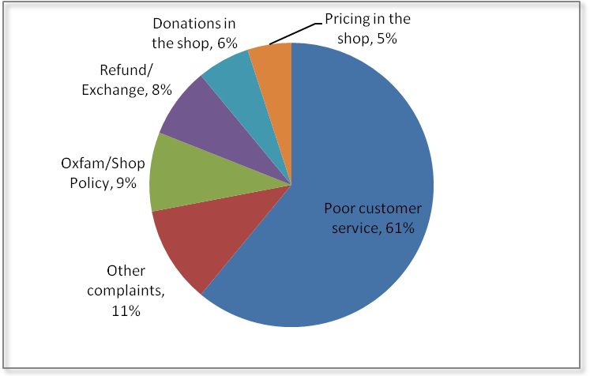
A breakdown of complaints made by donors, customers and volunteers about Oxfam’s Trading activity, 2015-2016.

Trends and Figures
Complaints by category from volunteers, donors and supporters about Oxfam’s Trading activity, 2012-16.

Trading Com-plaints 2012-15 | 2012-13 | 2013-14 | 2014-15 | 2015-16 | ’15 vs ‘16 | Why the change in the last year?
Poor Customer Service | 299 | 227 | 187 | 223 | +20% | Unclear – theme is similar, mostly issues relating to attitude/behaviour of SMs/ Volunteers
Other Complaints | 68 | 79 | 67 | 42 | -37% | More resolved at shop level?
Policy/Quality | 225 | 98 | 56 | 32 | -43% | Established policy more resolved by shops?
Refund/Exchange | 82 | 46 | 45 | 28 | -38% | Established policy more resolved by shops?
Donation | 56 | 34 | 26 | 22 | -15% | Similar overall percentage to L/Y
Pricing | 71 | 29 | 25 | 18 | -28% | Similar overall percentage L/Y
TOTAL | 801 | 513 | 406 | 365 | -10%

A key indicator is to handle complaints within 14 days of initial receipt. On average Trading complaints took 13 days to resolve which demonstrates the same level of performance as 2014-2015. 37% took longer than the allotted 14 days. This is an increase on 2014-15, where 33% took over 14 days. It was identified last year that there was greater likelihood of breaching the 14 days when complaints are escalated to Area Managers and above. In many cases the delay can be due to the time it takes to go through the investigation process, involving multiple exchanges of correspondence before concluding/responding.

426 (65%) of Oxfam’s 652 shops did not have a complaint lodged against them in 2015-2016 which compares very favourably with 62% in 2014-15. This is not meant to suggest that there were no complaints in 426 shops but those received were handled successfully at a local level by Shop Management.

Poor customer service continues to be the primary cause of dissatisfaction. However this year it has increased to 61% of all complaints which is significantly higher than in any of the previous 5 years. As mentioned above, alongside this increase it means other types of complaint have all considerably reduced.

Learning 2015-16 and Actions 2016-17
For 2015/16 we undertook a number of initiatives to focus on effective identification/ management of complaints, including:
- Refresher Training for the whole Shop Support Team to ensure consistent and accurate application of complaints policy and to differentiate between complaints and feedback. This has remained a topic of discussion that is regularly revisited.
- Review of “complaints” and “report feedback” tags (headings) recorded on Tactile to sense check that the two were being correctly differentiated. Given the sometimes subjective nature of this there were a very small number of anomalies but nothing significant. This fed into further discussion at a team level.
- Every complaint is now cc’d to Area Managers at the outset to provide (1) more clarity around which shops are impacted and (2) the opportunity for them to intervene or offer support at the outset where it is considered necessary.
- Focus on volume of complaints over 14 days. Disappointingly the percentage has actually increased as a % of the lower overall volume. It is notable that of the lower overall complaint volume a much higher proportion relate to poor service/staffing where it is often necessary to escalate (which can stretch the timings). Higher percentages are also notable for other categories frequently requiring shop referral such as pricing and refunds.

Actions 2016-17:
- To get behind and understand the increase in volume of complaints relating to poor customer service.
- Volunteer training in the Shop Network 2016/17 an initial component of which is customer service.
- Track call volumes as the year progresses to identify any areas for process improvement.
- Continued focus on resolutions outside 14 days and, more specifically, whether the customer service training will support a reduction in service complaint volumes and those outside 14 days.
- Half year sense-check of data to ensure that complaints continue to be properly differentiated from feedback.
- Regular discussions/refreshers at Team Meetings to ensure correct procedures are consistently applied.

Support Relations
Progress and Actions
All complaints, apart from two, were handled within 14 days of receipt, which is in line with the departmental standard. The two complaints handled outside of the 14 days of receipt took 16 days and 30 days to complete. These complaints were escalated and had a level of complexity, due to the need to gather information from external agencies and required further information from the supporter. Holding replies were sent in during these delays.

The average time taken to handle a complaint was one working day with most requiring standard or fairly straightforward responses. 4% of complaints took longer than 4 days to deal with (3% increase on 2014-15).

Non-fundraising complaints (website issues, campaigns and Oxfam the Organisation complaints) have historically accounted for over a third of the overall number of complaints being recorded. This year has seen a significant reduction in these type of complaints - Oxfam the Organisation (214 v 93), Campaigning complaints (342 v 165) which represents a reduction of over 50%. Website complaints have also reduced (637 v 373), this has been a focal point in the past to reduce the complaint count, and to increase customer/supporter satisfaction.

On Fundraising complaints, we have seen an increase across most of the fundraising channels, Telemarketing, Supporter Mail, Door to Door and Street Fundraising, an area of major attention last year, due to reports in the press. Despite the cancellation of Oxfam calling activity for some months (following coverage by the press) Oxfam continued to receive complaints about our fundraising activities.

Fulfilment complaints continue to decrease year on year (157 v 57). Other areas of success include reductions in Admin/donation complaints (198 v 117), and Online shop complaints (271 v 176) which include order chasing, refund requests, wrong items sent etc.

FRSB Complaints
Due to the activity in the press (May 2015) there has been a specific focus on FRSB complaints. Oxfam have seen an increase in complaint totals on our Fundraising activity, especially around Telemarketing, Warm mail, Email and Street Fundraising, but also a decrease in complaints on our Doorstep and SMS fundraising activity. In 2015 Oxfam did increase its overall fundraising activity and whilst we saw small increases in Oxfam’s complaint rate for 2015, those rates are still below the sector’s complaint rate for 2014

Trends and Figures
Complaint Type | 2014 Total | 2015 Total
Admin/Donation Error & Poor supporter Care | 198 | 117
Campaign Policy | 342 | 165
Data Protection | 26 | 22
Door to Door | 266 | 383
E-Marketing | 59 | 56
Events & Fundraising | 58 | 20  Complaints received by Oxfam’s Supporter Relations Team covering the period March 2015 – April 2016
Fraudulent Donation | 3 | 17
Fulfilment Error | 157 | 57
Gift Aid/Tag Your Bag issues | 84 | 121
Supporter Mail Quantity/Marketing/Content | 115 | 216
Online Advertising | 11 | 5
Online Shop Complaints | 271 | 176
Online Shop Website issues | 516 | 333
Oxfam the Organisation | 214 | 93
Private Site | 0 | 2
Shop Complaint | 37 | 17
SMS | 61 | 23
Street Fundraising | 116 | 181
Telemarketing | 493 | 702
TV Advertising | 12 | 5
Website/My Account issues | 121 | 40
Grand Total | 3160 | 2751

Complaints received by Oxfam’s Supporter Relations Team covering the period March 2015 – April 2016
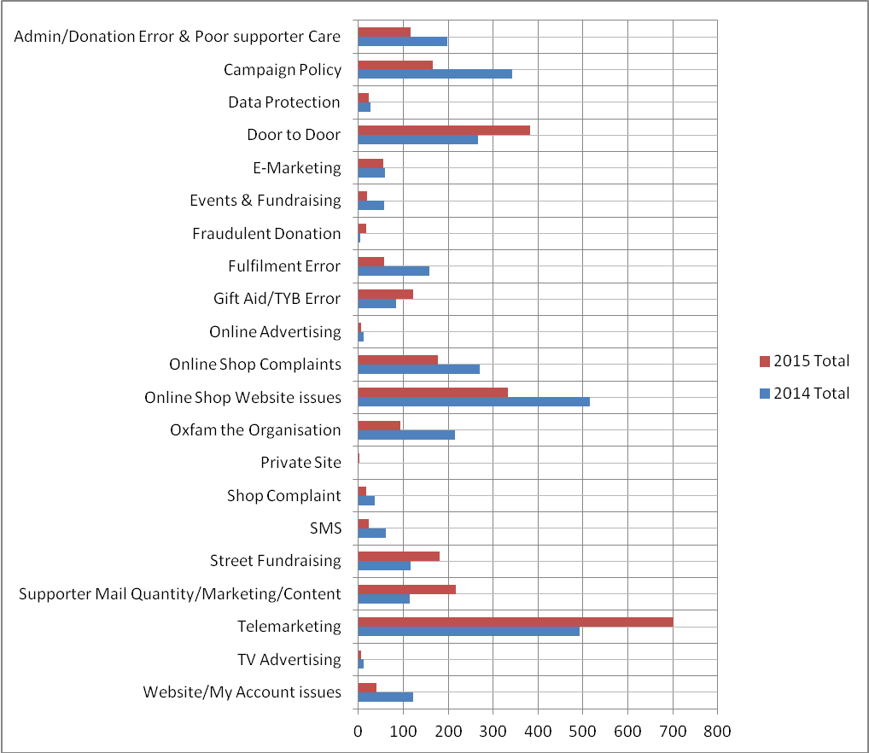
The following comparison table, shows the top 6 public fundraising method complaints received by Oxfam’s Supporter Relations Team, reported to the FRSB, covering the period January 2014 – December 2015
Fundraising Method | Activity Volume 2014 | No. of Complaints 2014 | % Complaint Rate 2014 |  | Activity Volume 2015 | No. of Complaints 2015 | Oxfam Complaint Rate 2015  % | Oxfam Complaint Rate vs 2014 % | Sector Complaint Rate 2015
Fundraising Method | Activity Volume 2014 | No. of Complaints 2014 | Oxfam | Sector
Telephone | 672069 | 411 | 0.061 | 0.135 | 1109830 | 732 | 0.066 | 0.005 | TBC
Warm Mail | 2845697 | 181 | 0.006 | 0.034 | 3327806 | 328 | 0.010 | 0.003 | TBC
Email | 8465344 | 41 | 0.000 | 0.009 | 14438339 | 103 | 0.001 | 0.000 | TBC
Doorstep | 278580 | 380 | 0.136 | 0.077 | 2129247 | 428 | 0.020 | -0.116 | TBC
Street | 16351200 | 130 | 0.001 | 0.005 | 2543940 | 155 | 0.006 | 0.005 | TBC
SMS | 405768 | 64 | 0.016 | 0.010 | 1383612 | 16 | 0.001 | -0.015 | TBC
Latest sector rates will be available from the FRSB around July 2016

Learning 2015-16 and Actions 2016-17
A number of actions were taken during 2015-16, which included the following:
- Staff training continues to be implemented in direct response to learning, feedback and an increase in more challenging contacts i.e. Vulnerable people
- Supporter Relations have been producing monthly reports for fundraising teams and campaigns. The processes and procedures were not currently recorded on our internal web pages, but are now recorded and the team trained up on how to access this information, to help support future training
- Complaint information is valuable and needs to be shared more widely

Actions for 2016-17
- Supporter Relations to continue training on Complaints and Vulnerable people processes, at least twice a year.
- Use the training team to quality check feedback logged and to ensure team learn from feedback.
- Produce monthly reports for FLT and compliance manager, keep an eye on trends and raise awareness to any particular peaks.

Appendix 1
Progress Reports against 2015-16 Action Plan
Complaints Group Disseminate Global Complaints Policy  Trading Understand the issue that prevents resolution within 14 days and determine what we can do to speed up the process  Look at shops where there may be particular issues to help improve customer service levels based on issues identified.  Supporter Relations  - Continue regular quarterly monitoring of Fundraising complaints and add a deep diver approach to one key area this year – Telemarketing.  - Producing quarterly reports of complaints and feedback, fundraising activity levels so the rate can be monitored vs sector data. To share Fundraising Leadership Team and other key audiences.  - Further develop our new social media monitoring tool to produce reporting from these key channels of complaints and feedback using the categorisation in place for other channels.  Programme  - 3 more Accountability Reviews carried out by independent consultants on randomly selected Oxfam projects. Information gleaned from these reviews will be utilised to produce learning materials.  - Utilise the One Oxfam Report and Global Complaints Policy as ‘hooks’ to raise awareness on the need to hear what people are saying about our work, record it, react to it and then pass it on for further learning. | Incomplete. OI policy not yet available. OGB’s policy to remain in place.  Partially complete. Carry forward to 2016/17 action plan  Partially complete. Carry forward to 2016/17 action plan.  Complete  Data is now monitored internally and shared with Fundraising Leadership Team sector data isn’t readily available.  Complete.  Complete  The signing of a cross-confederation Complaints Policy stalled for the duration of the reporting period due to review and structural changes within OI. OGB’s policy has therefore remained in place. .

Appendix 2
2016-17 Action Plan
Complaints Group
To hold 2 meetings and maintain an overview of complaints activity and learning throughout the year.

Trading
Understand the issue that prevents resolution within 14 days and determine what we can do to speed up the process
Look at shops where there may be particular issues to help improve customer service levels based on issues identified.

Supporter Relations
Supporter Relations to continue training on Complaints and Vulnerable people processes, at least twice a year.
Use the training team to quality check feedback logged and to ensure team learn from feedback
Produce monthly reports for FLT and compliance manager, keep an eye on trends and raise awareness to any particular peaks

Programme
The advent of the One Oxfam report will be used to raise awareness on the need to hear what people are saying about OGB’s work, record it, react to it and then pass it on for further learning.

Where OGB is the Executing Affiliate it will be compulsory for all partners and partnerships to have the capacity to identify, record and report complaints. The need for this capacity to be built/assured will be part of our Programme Quality ‘offer’ to the rest of the confederation.

